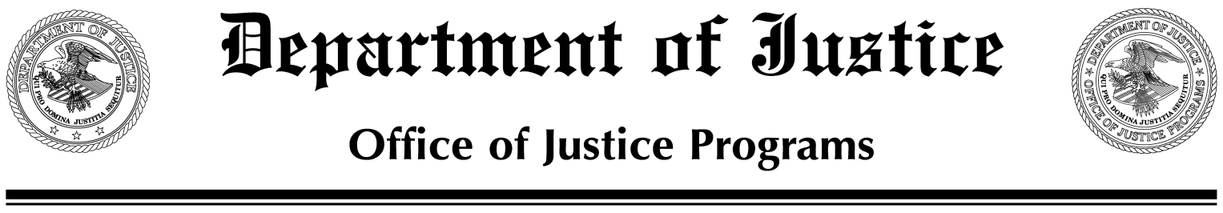
***EMBARGO UNTIL BUREAU OF JUSTICE STATISTICS
THURSDAY, JULY 8, 2021, 10 A.M. ET CONTACT: TANNYR WATKINS
bjs.OJP.gov (202) 532-3923; Tannyr.M.Watkins@ojp.usdoj.gov

U.S. ATTORNEYS INVESTIGATED MORE THAN 1,800 HATE CRIME SUSPECTS FROM 2005 TO 2019

WASHINGTON — U.S. attorneys investigated a total of 1,864 suspects in matters involving violations of federal hate crime statutes during fiscal years 2005 to 2019, the Bureau of Justice Statistics announced today. Hate crime suspects were referred for prosecution to U.S. attorneys from federal judicial districts in all 50 states.

Hate crimes are defined according to four statutes in the U.S. Criminal Code and collected by federal justice agencies. These include crimes in which the perpetrator selected the victim based on certain characteristics, such as race, color, religion, and national origin.

U.S. attorneys declined to prosecute 82% of suspects, prosecuted 17% and disposed of 1% for prosecution by U.S. magistrates. Insufficient evidence was the most common reason hate crime matters were declined for prosecution.

Among the 310 defendants adjudicated in U.S. district court for hate crime violations during 2005-19, more than 9 in 10 defendants (284) were convicted. About 85% (240) of those convicted of a hate crime were sentenced to prison, with an average term of over 7.5 years. About 14% (39) were sentenced to probation only, and 1% (4) received a suspended sentence. Forty percent of the convictions for hate crimes during 2005-19 occurred in federal judicial districts in six states: New York (30), California (26), Texas (19), Arkansas (15), Tennessee (13) and Pennsylvania (12).

During the most recent 5-year period of 2015-19, the conviction rate for hate crimes increased to 94%, up from 83% during 2005-09. During the same period, the number of hate crimes investigated by U.S. attorneys for prosecution fell 8%, from 647 during 2005-09 to 597 during 2015-19. Nearly half (48%) of the suspects investigated for a hate crime during 2015-19 were referred to U.S. attorneys for violating the Hate Crimes Prevention Act (HCPA).

Over the 15-year period from 2005-19, U.S. attorneys most often (22%) prosecuted hate crimes as part of other charges, followed by hate crimes involving damage to religious property (19%), violations of the HCPA (18%) and fair housing violations (16%). Most (63%) hate crime matters

– MORE –
investigated by U.S. attorneys during 2005-19 involved one suspect, while 37% involved multiple suspects. The number of suspects ranged from 2 to 10 persons per matter. Hate crime matters over fair housing (47%) and HCPA (44%) violations were the most likely to involve multiple suspects. Matters involving damage to religious property (22%) were the least likely to involve multiple suspects.

The report, Federal Hate Crime Prosecutions, 2005–19 (NCJ 300952), was written by BJS statistician Mark Motivans, Ph.D. The report, related documents and additional information about BJS’s statistical publications and programs are available on the BJS website at bjs.ojp.gov.

The Bureau of Justice Statistics of the U.S. Department of Justice is the principal federal agency responsible for collecting, analyzing and disseminating reliable statistics on crime and criminal justice in the United States. Doris J. James is the acting director.

The Office of Justice Programs provides federal leadership, grants, training, technical assistance and other resources to improve the nation’s capacity to prevent and reduce crime, advance racial equity in the administration of justice, assist victims and enhance the rule of law. More information about OJP and its components can be found at www.ojp.gov.

###

